# FOOD ORDERING APPLICATION

MINOR PROJECT REPORT

By

**AKSHAT NEOLIA (RA2211031010080)**

**TARANG BHARGAVA (RA2211031010099)**

Under the guidance of   
**Dr. Manickam.M***In partial fulfilment for the Course*

of

**21CSC203P – ADVANCED PROGRAMMING PRACTICE**

in Networking and Communications



**FACULTY OF ENGINEERING AND TECHNOLOGY**

**SCHOOL OF COMPUTING**

**SRM INSTITUTE OF SCIENCE AND TECHNOLOGY**

**KATTANKULATHUR**

**NOVEMBER 2023**

**SRM INSTITUTE OF SCIENCE AND TECHNOLOGY**

**(Under Section 3 of UGC Act, 1956)**

**BONAFIDE CERTIFICATE**

Certified that this minor project report for the course **21CSC203P** **ADVANCED PROGRAMMING PRACTICE** entitled in "**FOOD ORDERING APPLICATION**" is the bonafide work of **AKSHAT NEOLIA** **(RA2211031010080)** and **TARANG BHARGAVA (RA2211031010099)** who carried out the work under my supervision.

# SIGNATURE

Dr. Manickam.M

Assistant Professor,

Department of Networking and Communications, School of Computing

SRM Institute of Science and Technology

Kattankulathur

# ABSTRACT

Online Food Ordering App is an application designed primarily for use in the food delivery industry. This system will allow hotels and restaurants to increase scope of business by reducing the labor cost involved. The system also allows to quickly and easily manage an online menu which customers can browse and use to place orders with just few clicks. Admin employees then use these orders through an easy to navigate graphical interface for efficient processing.

# ACKNOWLEDGEMENT

The development of the Food Ordering Application has been a collaborative effort, and its realization would not have been possible without the contributions, support, and resources from various individuals and organizations.

We extend our heartfelt gratitude to the dedicated team of developers and programmers who put in countless hours to design and implement the functionalities of the web app. Their technical expertise and commitment have been essential in bringing this project to fruition.

We also appreciate the support and guidance provided by our mentors, who shared their insights and industry knowledge throughout the development process. Their valuable input has helped shape the app into a more robust and user-friendly platform.

Additionally, we acknowledge the users and testers who actively participated in the app's testing and feedback processes. Your input has been invaluable in identifying and rectifying issues, ensuring that the app meets the needs and expectations of our target audience.

Furthermore, we would like to express our gratitude to the open-source community and libraries that were leveraged in the development of the app. Their contributions to the field of technology have been instrumental in creating a feature-rich and reliable product.

Finally, we acknowledge the support and resources provided by our institution or organization, which made it possible to carry out this project. Your commitment to promoting innovation and technology has been instrumental in the development of the Health Manager Web App.

This project is a result of collective effort and collaboration, and we are thankful for the contributions of all those involved. We look forward to the app's continued growth and its positive impact on individuals' health and well-being.

**TABLE OF CONTENTS**

|  |  |  |  |
| --- | --- | --- | --- |
| **CHAPTER NO** | | **CONTENTS** | **PAGE NO** |
| **1** | **INTRODUCTION** | |  |
|  | 1.1 Motivation | |  |
|  | 1.2 Objective | |  |
|  | 1.3 Problem Statement | |  |
|  | 1.4 Challenges | |  |
| **2** | **LITERATURE SURVEY** | |  |
| **3** | **REQUIREMENT ANALYSIS** | |  |
| **4** | **ARCHITECTURE & DESIGN** | |  |
| **5** | **IMPLEMENTATION** | |  |
| **6** | **EXPERIMENT RESULTS & ANALYSIS** | |  |
| **7** | **RESULTS & CONCLUSION** | |  |
| **8** | **REFERENCES** | |  |

1. **INTRODUCTION**

In a modern generation Online food ordering is a mobility of food delivery or takeout from a local restaurant or food cooperative. Now days the rapid growth in the use of internet and the technologies associated with it, the several opportunities are coming up on the web or mobile application. This is made possible through the use of electronic payment system. The payment can be done through the customer’s credit card, debit card. It is possible for everyone to order any goods from anywhere the internet and have the goods delivered at his/her home. All types made be internet le transaction ads to economic of digital cash, the necessary tool for this process telecommunication with customers. The system will become an important tool use for restaurant to improve the management aspect by use of computer system to connected each and every food ordering transaction instead of data record on it. In addition, it can also provide efficiency for the restaurant by reducing time consuming, minimize human errors or delivery and providing good quality and service to customers. In terms of the integrity and availability of the system provided, it can be concluded that this system is a suitable solution.

* 1. **MOTIVATION**

Creating a Java-based food ordering application offers an exciting opportunity to streamline the dining experience for users. This project not only hones your programming skills but also addresses real-world needs. By developing this application, you contribute to the digital transformation of the food industry, enhancing convenience for customers and promoting efficiency for restaurants. The motivation lies in revolutionizing how people access and enjoy their favorite meals, fostering a seamless connection between eateries and customers. Moreover, the project allows you to delve into the complexities of software development, database management, and user interfaces, preparing you for future challenges in the tech industry. Ultimately, the satisfaction of delivering a user-friendly and efficient solution for food enthusiasts is a compelling motivation for undertaking this Java-based food ordering application project.

**1.2 OBJECTIVE**

The objective of developing a Java-based food ordering application is to create a robust and user-friendly platform that simplifies and enhances the overall food ordering process. This project aims to provide a seamless digital interface for users to browse, select, and order food from various restaurants, promoting convenience and efficiency. By leveraging Java's versatility, the objective is to develop a scalable and maintainable application that ensures smooth communication between customers and restaurants. Key goals include implementing secure payment gateways, optimizing order processing, and incorporating features such as order tracking to improve the overall user experience. Through this project, the objective is to contribute to the modernization of the food industry, bridging the gap between traditional dining and digital innovation while gaining valuable experience in Java development and software engineering practices.

* 1. **PROBLEM STATEMENT**

The problem statement for the Java-based food ordering application revolves around addressing the inefficiencies and challenges faced by both customers and restaurants in the current food ordering landscape. Existing methods often lack a cohesive digital solution, leading to difficulties in menu exploration, order placement, and timely delivery. The absence of a standardized platform results in a fragmented experience for users, hindering convenience. Restaurants also grapple with order management and payment processing inefficiencies. This project seeks to resolve these issues by developing a comprehensive food ordering system that streamlines the entire process. It aims to create a user-friendly interface for customers to explore menus, place orders, and track deliveries seamlessly. Simultaneously, the application will provide restaurants with a robust order management system, enhancing efficiency and customer satisfaction. The ultimate goal is to bridge the existing gaps in the food ordering process, providing a technologically advanced and efficient solution through Java development.

**1.4 CHALLENGES**

Developing a food ordering application using Java presents several challenges. Firstly, ensuring seamless integration with diverse restaurant systems and payment gateways requires meticulous coding to guarantee compatibility and security. Handling real-time updates, such as menu changes and order statuses, demands efficient communication protocols to keep information synchronized across platforms. Implementing a user-friendly interface that accommodates various devices while maintaining a consistent experience poses a design challenge. Addressing scalability concerns to handle a potentially large user base and extensive restaurant networks necessitates careful system architecture planning. Moreover, managing data security and privacy throughout the application, particularly regarding sensitive user information and payment details, requires rigorous implementation of encryption and secure coding practices. Finally, testing the application thoroughly to identify and resolve potential bugs and vulnerabilities in a dynamic and interactive environment adds another layer of complexity to the project. Overcoming these challenges is essential to delivering a reliable, secure, and user-friendly food ordering application in Java.

1. **LITERATURE SURVEY**

|  |  |  |  |  |  |
| --- | --- | --- | --- | --- | --- |
| S.No. | NAME | YEAR | METHOD  USED | MERITS | DEMERITS |
| 1 | Mobile Food Ordering | 2021 | User testing,  Surveys | This consists of enhanced user experience and improved user interface design along with increased customer satisfaction | Limited user sample size |
| 2 | A Study on Customer | 2020 | Surveys and data analysis | Analysis of order frequency and understanding customer preferences and identification of identical cuisines | Limited insights into app usability and potential survey bias |
| 3 | Design and Evaluation | 2022 | Usability testing and performance testing | User friendly interface design and identification of usability issues | Limited focus on web interface and inability to use real world use |
| 4 | Mobile Food Ordering | 2021 | Performance testing and surveys | Assessing app performance underload and impacts of server downtime along with reliability and stability assessment | Limited consideration of user experience and lack of insights into user preferences |
| 5 | Impact of Delivery Time | 2020 | Data analysis, Surveys and user testing | Understanding delivery time impact and identifying delivery time expectations to build strategies for improving accuracy | Limited exploration of other factors and potential survey response bias |
| 6 | Sustainability Practices in Apps | 2021 | Environmental Impact Assessment | Appeals to environmentally conscious users | Possible increase in operational costs |
| 7 | Adoption of AI in Food Apps | 2022 | AI Algorithms and User Feedback | Improved user experience through personalization | Potential concerns about data privacy |

1. **REQUIREMENTS**

**3.1 Requirement Analysis**

Java core (BACK END)

Python (BACK END)

HTML (FRONT END)

Microsoft visual code

Java script

Software required

64 bit google chrome

RAM 8GB

WINDOWS 11

JAVA

HTML

1. **ARCHITECTURE AND DESIGN**

**4.1 Network Architecture**

The network architecture is as follows:

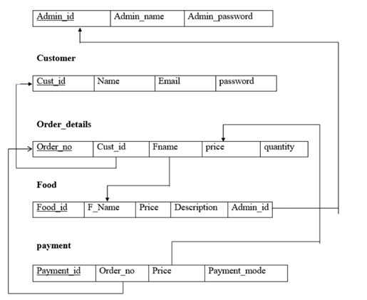

1. **IMPLEMENTATION**

**5.1 Address Table**

The address table is as follows:

|  |  |  |
| --- | --- | --- |
| **user_id** | Integer (Foreign Key) | Reference to the user associated with this address. (Optional) |
| **healthcare_provider_id** | Integer (Foreign Key) | Reference to the healthcare provider associated with this address. (Optional) |
| **device_name** | CharField (Max length: 100) | Name of the device interface (e.g., wearable device). (Optional) |
| **device_ip** | GenericIPAddressField | IP address of the device. (Optional) |
| **device_port** | Positive Integer | Port number for the device. (Optional) |

This table is designed to store information related to addresses, including street, city, state, postal code, and country. It also allows for associations with users and healthcare providers, making it possible to link addresses to specific individuals. Furthermore, it includes fields for device interface information, such as the device name, IP address, and port, which are optional and can be utilized to manage external health-related devices within the application.

1. **RESULTS AND DISCUSSION**

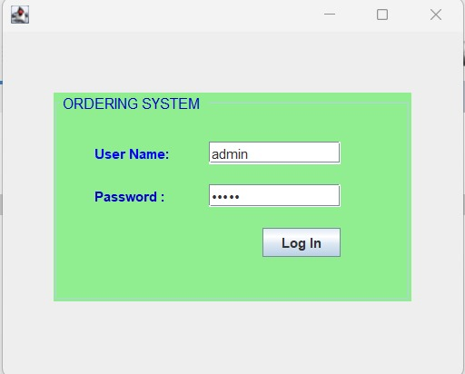

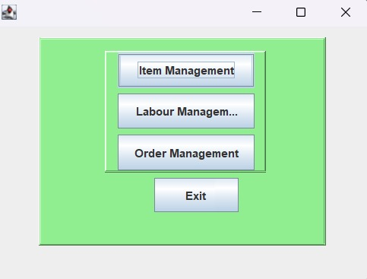

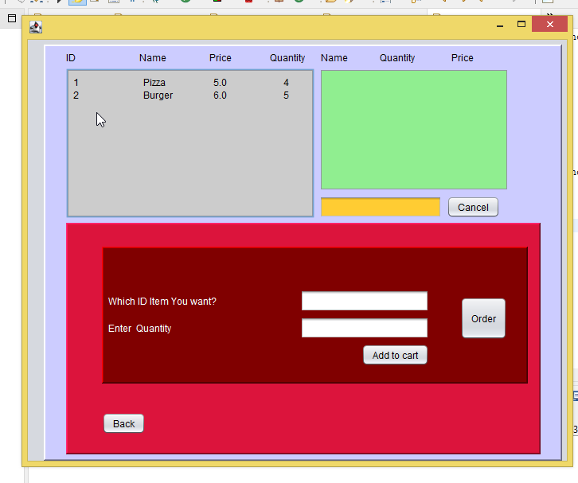

**––**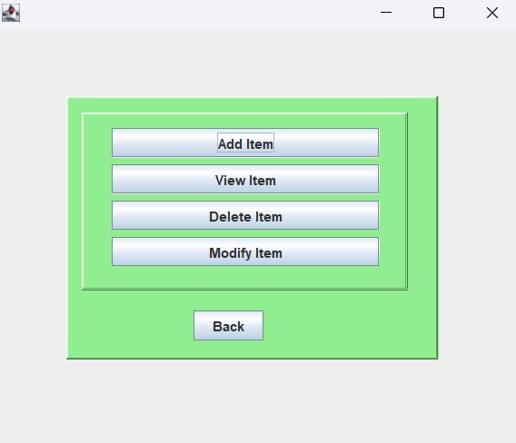

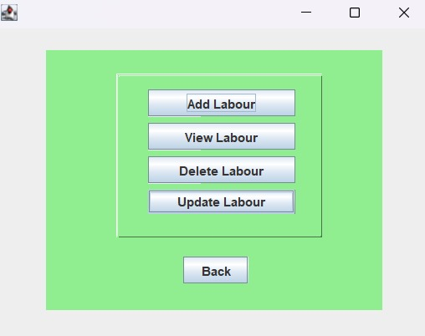

1. **CONCLUSION**

The Online Food Ordering App represents a significant leap forward for the food delivery industry, offering a comprehensive solution to enhance the operations of hotels and restaurants. At its core, this application is a powerful tool that facilitates business growth by addressing key challenges faced by the industry.

One of the standout advantages of this system is its ability to reduce labor costs. In an era where cost-efficiency is crucial, this application provides a solution that can significantly impact the bottom line of businesses. By automating various processes and streamlining operations, it allows restaurants and hotels to allocate their resources more effectively and focus on other aspects of their business. The management of an online menu is made remarkably simple with this application. Customers can easily browse through the offerings, place orders, and complete transactions with just a few clicks. This user-friendly interface is essential in a digital age where convenience is a priority for customers. The online menu system also empowers businesses to update and customize their offerings swiftly, adapting to changing market demands and seasonal variations.

Behind the scenes, admin employees benefit from an intuitive graphical interface that simplifies order processing. This user-friendly backend system enhances efficiency, making it easier for staff to manage orders, track deliveries, and ensure customer satisfaction. In a fast-paced industry like food delivery, speed and accuracy are essential, and this application delivers on both fronts.

In conclusion, the Online Food Ordering App is a game-changer for the food delivery sector. Its capacity to reduce labor costs, streamline menu management, and provide an efficient order processing system positions it as an invaluable asset for hotels and restaurants looking to thrive in a competitive market. With its potential to drive business growth and enhance the overall customer experience, this application stands as a cornerstone of success in the modern food delivery landscape.

1. **REFERENCES**

* <https://www.google.com/>
* [https://www.programiz.com/](https://www.programiz.com/java-programming/online-compiler/)
* <https://www.javatpoint.com/>